HUM 1020 SPRING TERM 2013
Intro to HUMANITIES COURSE SYLLABUS

INSTRUCTOR: Ed Szymanski Jr.

PHONE: Office: (407) 582-2285

E-MAIL: eszymanski@valenciacollege.edu

OFFICE: 1-346

HOURS: Office: MW – 8:00-10:00 a.m. & 11:30 a.m.-1:00 p.m online.
TR – 11:30 a.m.-12:30 p.m.

TEXTS: Sporre:: The Creative Impulse

CREDIT HOURS: 3

COURSE DESCRIPTION:

An integrated examination of the cultural expressions of art, literature, music, philosophy, and religion. This course covers the period from the Ancient World to the modern era….. emphasizing the synthesis of classical, secular, and religious elements. Non-western cultures will also be examined, significantly those that were impacted by European exploration and conquest.

VALENCIA CORE COMPETENCIES:

Valencia College has defined four interrelated competencies that help prepare students to succeed in the world community. These core competencies are Think, Value, Communicate, and Act. More specifically,
• Think clearly, critically and creatively by analyzing, synthesizing, integrating, and evaluating symbolic works and truth claims.
• Reflect on your own and others’ values from individual, cultural, and global perspectives.
• Communicate by reading, listening, writing, and speaking effectively.
• Act purposefully, reflectively, and responsibly by implementing effective problem solving and decision making strategies.
COURSE COMPETENCIES:

The discipline of the humanities involves an array of cognitive processes that will help lead you toward mastery of diverse and complex competencies. Among the competencies that this course will enable you to perfect are the following: resource materials, showing sensitivity toward other perspectives and cultures, participating in cultural experiences, articulating connections between the humanities and your life, integrating artistic, philosophical, and historical elements of the cultural period, arguing a point of view, tracing the development of style and form, and using technology effectively.

COURSE OBJECTIVES:

I. To trace the historical and cultural developments that shaped the early to the modern world.
II. To analyze and evaluate the impact of early and modern cultures on Western culture.
III. To analyze and interpret the article trends of the in painting, sculpture, and architecture.
IV. To discern the impact of European expansion and technology on global civilizations during these eras. .
V. To trace the steps of the philosophy and the establishment of Democracy and examine their impact on World history and culture.
VI. To examine the rise of science during the ancient world to the modern era period.
VII. To interpret works of the major writers of these periods.
VIII. To develop and embrace work place skills through the practice of effective oral and written communication through collaboration with other students, through the practice of leadership skills and through the intention of technology in research techniques.
IX. To encourage students through readings, discussion, debates, classroom activities, and through written work to become open to global cultures and through an examination of the past to clarify the cultural values of the present.
ESSAYS/TESTS:

There will be four to five major tests in this course, including the final exam. These tests will ask students to reflect upon the readings, as well as material covered in class, including lectures, discussions, power points, art discussions, and films. To help with reading comprehension and to prepare for the tests, please complete the study guides that accompany each chapter. Using these study aids should enhance understanding and appreciation of the material in each chapter.
The test essays will require additional research upon the part of the students. Students will be given the essay prompts in advance through the Course Homepage in order to thoroughly prepare for these writing assignments. Students will be asked to write thoughtfully, to identify works of art, and to answer objective questions on each test.

CULTURAL ACTIVITIES:

This course will include opportunities for cultural experiences both on campus and in the community. Students will be asked to reflect on two of these cultural experiences using a form that is found on Blackboard. Up to 10 points of extra credit will be given for attendance and reflections on a third cultural experience. Please reserve your tickets, receipts, or brochures as proof of attendance.

CLASS PARTICIPATION:

Each student is expected to participate actively in class. Throughout the semester, students will have opportunities for class discussion, individual initiative, short “lectures” and group projects. Short, informal, “writing prompt” assignments will be given to stimulate thinking and class discussion.

CLASS ATTENDANCE AND PREPARATION:

Class attendance is essential to your success in this class. Furthermore, attendance is necessary for your preparation in class discussions that are a major part of this course ‒ and therefore a major part of your grade. You can participate in class discussions and group projects only if you are present in class and prepared for class. Students are responsible for informing themselves of material covered in class during an absence.

Reading preparation is also essential to your success in this class. Many test questions will be based upon the material in the readings and the text material that we will not routinely cover in class. Remember to use the material from your study guides to help you prepare for class discussion and tests.

Students with excessive class absences (i.e., 3 or more) will suffer a grade penalty. If you stop attending the class and do not withdraw, you will be given an F at the end of the term. If you intend to withdraw, please do so before the deadline of March 22, 2013, to avoid adverse consequences.

CLASS PARTICIPATION CHECK-LIST:

The following behaviors will result in a high class participation grade:
- Perfect or near-perfect attendance
- Always on-time to class
- Attentive in class
- Prepared for class
- Volunteers for class activities, discussions
- Reads passages aloud
- Initiates a topic or idea based on class material
- Willing to give personal reactions
- Encourages classmates
- Asks pertinent questions
- Treats everyone in class with dignity and respect

The following behaviors will result in a low class participation grade:
- Absences
- Late to class
- Interrupts others
- Private conversations
- Monopolizes discussions
- Sarcastic or negative remarks
- Show disrespect toward others
- Texting or Cell-phone usage
- Does homework in class
- Mental apathy, absences, sleeping

CELL PHONE POLICY:

There will be no cell phone/iphone usage in class. THIS MEANS NO TEXTING!!!!
(See student conduct and classroom behavior instructions below).

WITHDRAWAL FROM THE CLASS:

A student is permitted to withdraw from the class on or before the withdrawal deadline, as published in the College calendar. A student is not permitted to withdraw from the class after the withdrawal deadline. To receive a W, you must withdraw before the withdrawal deadline on March 22, 2013. Students who simply stop attending class and fail to withdraw by
March 22, 2013, will receive an F.
If you have any questions, please consult the college catalogue.

STUDENT CONDUCT AND CLASS BEHAVIOR:

Valencia College is dedicated to promoting honorable personal and social conduct. By enrolling at Valencia, a student assumes the responsibility for knowing and abiding by the rules articulated in the Student Code of Conduct (6Hx28:10-03). The instructor reserves the right to refer students who engage in activities that are disruptive to the learning environment to the Dean of Students for disciplinary action. The following list, though not exhaustive, includes things which are disruptive to the learning environment:

Use of any electronic devices including but not restricted to: Cell phones, iPods, and laptop computers (documentation from OSD will be taken into consideration).

Preparing homework for this course or other courses during class.

Engaging in private conversations with classmates while class is in session.

Excessive tardiness.

Leaving and re-entering the classroom while the class is in session.

In addition, Valencia College strives to provide a drug-free learning environment for all those involved in the academic experience. Our policy is as follows:

Policy:

In compliance with the provisions of the Federal Drug-Free Schools and Communities Act of 1989, Valencia College will take such steps as are necessary in order to adopt and implement a program to prevent the unlawful possession, use, or distribution of illicit drugs and alcohol by Valencia College students or employees on college premises or as part of any college activity.

STUDENTS WITH DISABILITIES:

Students with disabilities who quality for academic accommodations must provide a notification from the Office for Students with Disabilities (OSD) and discuss specific needs with the instructor, preferably during the first two weeks of class. The Office for Students with Disabilities determines accommodations based on appropriate documentation of disabilities. The East Campus Office is located in Building 5, Room 216.

EVALUATION PROCESS:

You will receive a numerical grade for all your assignments. Your final grade will be based upon the cumulative total of points divided by the total number of points possible.
The grading scale will be
90-100 = A; 80-89= B; 70-79 = C; 60-69 = D; 0-59 = F. All assignments and tests must be completed to receive credit for the class.

MAKE-UP POLICY:

Make-up tests will be given only in cases of unavoidable conflict. (documentation showing reason for emergency must be offered; otherwise, late points will be deducted).

ACADEMIC HONESTY:

The class will be conducted in a positive manner reinforced by the personal, moral commitment of each student to complete his/her work independently. Any instance of plagiarism or cheating will result in loss of credit.

MAJOR ASSIGNMENTS:

Points Assignments Words
100 Test 1 750
100 Test 2 750
100 Test 3 750
100 Test 4 (Exam) 750
100 Cultural Paper 500
100 Attendance, Class Participation

STUDENT ASSESSMENT OF INSTRUCTION:

This term you will receive an invitation through your Valencia e-mail account asking you to complete the Student Assessment of Instruction (SAI) to provide us with feedback on your experience in this class and to help us to improve the course. The results are released only after grades are submitted. Student names are not included in the results ‒ your responses will be anonymous. Please send your feedback to Valencia through the SAI when it opens. We want to learn more about your experiences while we continually improve our courses.

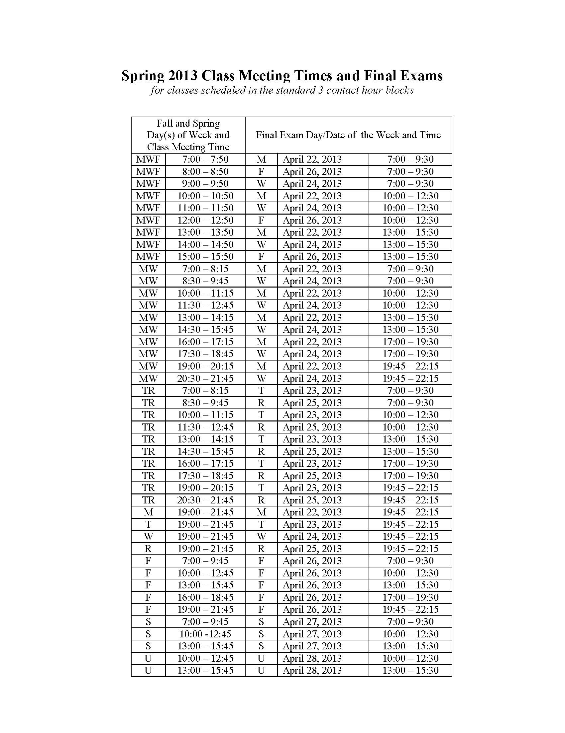

Please note that this information will forwarded to you ASAP

HUM 1020
Course Schedule – Spring Term 2013
Prof. Ed Szymanski Jr. (Mr. Ed)

Defining abbreviations:

CV - Culture and Values CWT - Classics of Western Thought Rpkt. - reading packet

Week of 01/7
Week of 01/07 – 01/10
Week of 01/14 – 01/17
Week of 01/21 – 01/24 | COLLEGE CLOSED 01/21 MLK Day
Week of 01/28 – 01/31 | Review Test and Essays
Week of 02/04 -02/07
Week of 02/11 – 02/14
Week of 02/18 – 02/21
Week of 02/25 – 02/28
Week of 03/04 – 03/10 | SPRING BREAK – COLLEGE CLOSED

Week of 03/11 – 03/14
Week of 03/18 – 03/21
Week of 03/25 – 03/28
Week of 04/01 – 04/04
Week of 04/08 – 04/11
Week of 04/15 – 04/18
Week of 04/22 – 04/25 | Final Exam:

DISCLAIMER: Please note that this document is only a framework and is to be used as guideline. Changes may be made during the course of the term but students will always be given notifications via email and in class announcements.

